https://fsd.tcsbank.ru/case/4100105/info
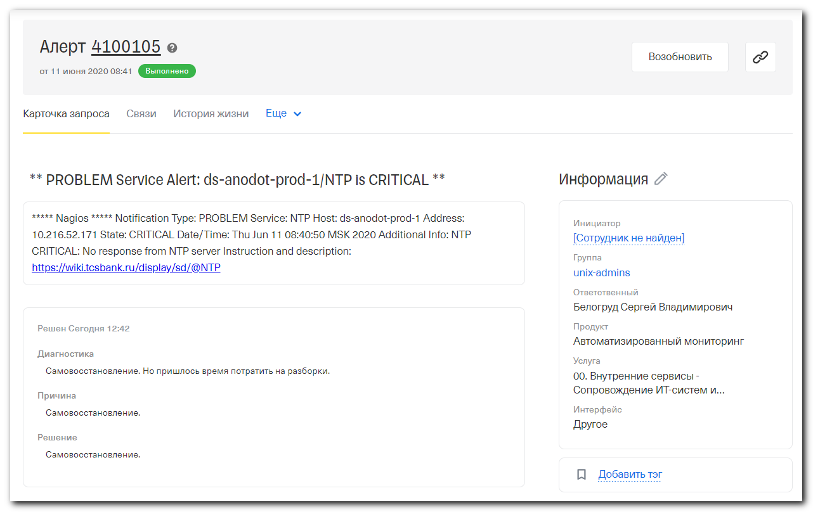
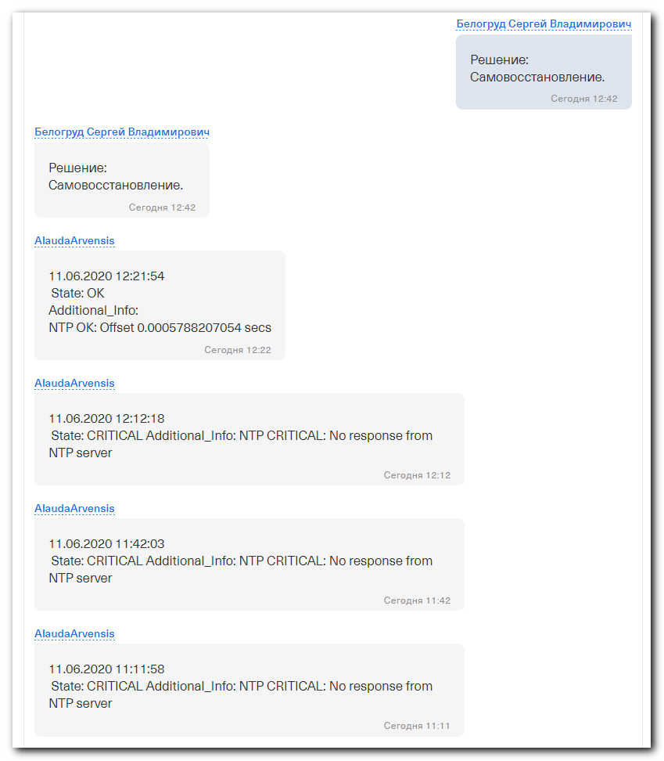

# Вот странная ерунда. Сработало оповещение из nagios на проверку ntp.

# Проверка в nagios стандартная. Без упоминания об chrony.
define service{
use generic-service-ntp
host_name ds-anodot-prod-1
service_description NTP
service_groups Clock offset - Service Group
contacts empty_contact
contact_groups linux-admins
check_command check_nrpe!check_ntp_time
}

#
# Ещё на сервере таймзона не московская!
# Трогать не стал - может оно так им и надо.
root@ds-anodot-prod-1:~# date
Thu Jun 11 08:38:11 UTC 2020
root@ds-anodot-prod-1:~# chronyc sourcestats
210 Number of sources = 6
Name/IP Address NP NR Span Frequency Freq Skew Offset Std Dev
==============================================================================
of-c1-lo0.tcsbank.ru 6 3 85m -0.065 0.142 -1258us 66us
dc-c1-lo0.tcsbank.ru 7 4 51m +0.033 0.098 +529us 33us
dc-c2-lo0.tcsbank.ru 7 6 51m +0.007 0.159 +83us 59us
ds-nx1-lo0.tcsbank.ru 8 6 120m +0.044 0.090 +847us 85us
ds-nx2-lo0.tcsbank.ru 7 5 103m +0.017 0.037 +389us 26us
of-c2-lo0.tcsbank.ru 9 6 77m +0.039 0.059 -1234us 42us
root@ds-anodot-prod-1:~#

# На хосте установлено Ubuntu 18.04.2 LTS
# И установлен chrony. А ntp не установлен.
root@ds-anodot-prod-1:~# ntpq -nc pe

Command 'ntpq' not found, but can be installed with:

apt install ntp
apt install ntpsec

root@ds-anodot-prod-1:~#

#
# С puppet всё нормально.
#
root@ds-anodot-prod-1:~# puppet agent -t
Info: Using configured environment 'production'
Info: Retrieving pluginfacts
Info: Retrieving plugin
Info: Loading facts
Info: Caching catalog for ds-anodot-prod-1.tcsbank.ru
Info: Applying configuration version 'vm-puppetmaster02p.tcsbank.ru-production-7371574874a'
Notice: Applied catalog in 1.39 seconds
root@ds-anodot-prod-1:~# systemctl status chronyd
● chrony.service - chrony, an NTP client/server
Loaded: loaded (/lib/systemd/system/chrony.service; enabled; vendor preset: enabled)
Active: active (running) since Thu 2020-05-28 07:01:19 UTC; 2 weeks 0 days ago
Docs: man:chronyd(8)
man:chronyc(1)
man:chrony.conf(5)
Main PID: 1295 (chronyd)
Tasks: 1 (limit: 4915)
CGroup: /system.slice/chrony.service
└─1295 /usr/sbin/chronyd

Jun 09 10:49:26 ds-anodot-prod-1.tcsbank.ru chronyd[1295]: Selected source 172.20.16.194
Jun 10 09:30:49 ds-anodot-prod-1.tcsbank.ru chronyd[1295]: Can't synchronise: no majority
Jun 10 09:37:01 ds-anodot-prod-1.tcsbank.ru chronyd[1295]: Selected source 172.20.16.194
Jun 10 09:43:13 ds-anodot-prod-1.tcsbank.ru chronyd[1295]: Selected source 172.20.16.192
Jun 10 11:46:31 ds-anodot-prod-1.tcsbank.ru chronyd[1295]: Selected source 172.20.16.205
Jun 10 11:49:21 ds-anodot-prod-1.tcsbank.ru chronyd[1295]: Selected source 172.20.16.192
Jun 10 12:25:58 ds-anodot-prod-1.tcsbank.ru chronyd[1295]: Selected source 172.20.16.194
Jun 10 14:41:03 ds-anodot-prod-1.tcsbank.ru chronyd[1295]: Selected source 172.20.16.192
Jun 10 20:06:36 ds-anodot-prod-1.tcsbank.ru chronyd[1295]: Selected source 172.20.16.194
Jun 11 08:16:41 ds-anodot-prod-1.tcsbank.ru chronyd[1295]: Can't synchronise: no selectable sources
root@ds-anodot-prod-1:~#

#
# Если попытатьс поставить ntp то установщик напишет, что он удалит chrony и freeipa-client.
#
root@ds-anodot-prod-1:~# apt-get install ntp
Reading package lists... Done
Building dependency tree
Reading state information... Done
The following packages were automatically installed and are no longer required:
augeas-lenses bind9utils certmonger cracklib-runtime freeipa-common ieee-data ldap-utils libaugeas0 libbasicobjects0 libc-ares2 libcollection4 libcrack2 libcurl3-nss libdhash1
libhttp-parser2.7.1 libini-config5 libipa-hbac0 libjbig0 libjpeg-turbo8 libjpeg8 liblcms2-2 libnl-route-3-200 libnspr4 libnss-sss libnss3 libnss3-tools libnsspem libpam-pwquality
libpam-sss libpath-utils1 libpwquality-common libpwquality1 libref-array1 libsss-certmap0 libsss-idmap0 libsss-nss-idmap0 libsss-sudo libtiff5 libwebp6 libwebpdemux2 libwebpmux3
libxmlrpc-core-c3 oddjob oddjob-mkhomedir python-augeas python-bs4 python-cffi python-decorator python-dnspython python-gssapi python-html5lib python-ipaclient python-ipalib
python-jinja2 python-jwcrypto python-ldap python-libipa-hbac python-lxml python-markupsafe python-netaddr python-netifaces python-nss python-olefile python-pil python-ply
python-pyasn1 python-pyasn1-modules python-pycparser python-qrcode python-sss python-usb python-webencodings python-yubico python3-ply python3-sss sssd sssd-ad sssd-ad-common
sssd-common sssd-ipa sssd-krb5 sssd-krb5-common sssd-ldap sssd-proxy
Use 'apt autoremove' to remove them.
The following additional packages will be installed:
libopts25 sntp
Suggested packages:
ntp-doc
The following packages will be REMOVED:
chrony freeipa-client
The following NEW packages will be installed:
libopts25 ntp sntp
0 upgraded, 3 newly installed, 2 to remove and 103 not upgraded.
Need to get 785 kB of archives.
After this operation, 1,595 kB of additional disk space will be used.
Do you want to continue? [Y/n] n
root@ds-anodot-prod-1:~#

#
# Проверка на сервере сделана под ntp. Но напоминаю - самого ntp не поставлено!
#
root@ds-anodot-prod-1:~# grep -ire "check_ntp_time" /etc/nagios
/etc/nagios/nrpe.d/check_ntp.cfg:command[check_ntp_time]=NTP_SERVER=$(/usr/sbin/ntpq -pn | grep ^'*' | cut -d" " -f1 | cut -d'*' -f2) && /usr/lib/nagios/plugins/check_ntp_time -H ${NTP_SERVER:-ntp01.tcsbank.ru} -w 0.7 -c 1
root@ds-anodot-prod-1:~#

# Оказывается эта проверка работоспособна и без установленного ntp пакета!
# То есть ругается, но результирующий ОК всё же выдаёт (когда offset нормальный).
root@ds-anodot-prod-1:~# NTP_SERVER=$(/usr/sbin/ntpq -pn | grep ^'*' | cut -d" " -f1 | cut -d'*' -f2) && /usr/lib/nagios/plugins/check_ntp_time -H ${NTP_SERVER:-ntp01.tcsbank.ru} -w 0.7 -c 1
-bash: /usr/sbin/ntpq: No such file or directory
NTP OK: Offset 0.000104278326 secs|offset=0.000104s;0.700000;1.000000;
root@ds-anodot-prod-1:~#

root@ds-anodot-prod-1:~# /usr/lib/nagios/plugins/check_ntp_time -H ${NTP_SERVER:-ntp01.tcsbank.ru} -w 0.7 -c 1
NTP OK: Offset 0.0001438856125 secs|offset=0.000144s;0.700000;1.000000;
root@ds-anodot-prod-1:~#

#
# Через некоторое время проверка самопочинилась.
#
[root@vm-vol-nag4-tst objects]# /usr/local/nagios/libexec/check_nrpe -t 180 -H 10.216.52.171 -c check_ntp_time
NTP OK: Offset 0.0001094639301 secs|offset=0.000109s;0.700000;1.000000;
[root@vm-vol-nag4-tst objects]#

# А я-то вообще думал, что придётся ставить проверку заточенную под chrony.
# И я нашел, где такую можно взять.
[root@vm-vol-nag4-tst objects]# grep -irle "chron" servers/

[root@m1-pr-sp-02 ~]# grep -ire "chron" /etc/nrpe.d/
/etc/nrpe.d/nrpe_commands.cfg:command[check_chronyd_time]=/usr/lib64/nagios/plugins/check_linux_timesync_status.py -d chronyc
[root@m1-pr-sp-02 ~]#

[root@m1-pr-sp-02 ~]# cat /etc/nrpe.d/nrpe_commands.cfg
#
# Ansible managed
#

# Command NRPE
command[check_load_args]=/usr/lib64/nagios/plugins/check_load -r -w 1,1,1 -c 2,2,2
command[check_memory_load_linux]=/usr/lib64/nagios/plugins/check_mem_linux.pl -f -w 10 -c 5 -C
command[check_cpu]=/usr/lib64/nagios/plugins/check_cpu_stats.sh
command[check_total_procs]=/usr/lib64/nagios/plugins/check_procs -w 150 -c 200
command[check_zombie_procs]=/usr/lib64/nagios/plugins/check_procs -w 5 -c 10 -s Z
command[check_nf_conntrack_count]=/usr/lib64/nagios/plugins/check_nf_conntrack_count.sh
command[check_linkup]=/usr/lib64/nagios/plugins/check_linkup.sh
command[check_ntp_time]=/usr/lib64/nagios/plugins/check_ntp_time.sh
command[check_chronyd_time]=/usr/lib64/nagios/plugins/check_linux_timesync_status.py -d chronyc
command[check_openmanage]=/usr/lib64/nagios/plugins/check_openmanage -p
command[check_md]=/usr/lib64/nagios/plugins/check_md.sh
command[check_systemd_service]=/usr/lib64/nagios/plugins/check_systemd_service.sh $ARG1$

# Command NRPE-sudo
command[pwd-expire]=/usr/bin/sudo /usr/lib64/nagios/plugins/pwd-expire.sh
command[check_disk_all_local]=/usr/bin/sudo /usr/lib64/nagios/plugins/check_disk -W 10% -K 5% -w 10% -c 5% -A -X tmpfs -X devtmpfs -X squashfs -X overlay -X nsfs -X aufs -X securityfs -X configfs -X debugfs -X tracefs -X fuse.gvfsd-fuse -l -e
command[check_disk_db_nfs]=/usr/bin/sudo /usr/lib64/nagios/plugins/check_disk -N nfs -e -W 7% -K 3% -w 7% -c 3% -r '^/oramnt/.*$'
command[check_disk_nfs_others]=/usr/bin/sudo /usr/lib64/nagios/plugins/check_disk -N nfs -e -W 20% -K 10% -w 4 -c 3 -u GB -A -i '^/oramnt/.*$' -i '^/.*/.snapshot/.*'
command[check_free_ports]=/usr/bin/sudo /usr/lib64/nagios/plugins/check_free_ports.sh
command[check_vcs_tolerance]=/usr/bin/sudo /usr/lib64/nagios/plugins/check_logfiles --tag=vcs --logfile=/var/VRTSvcs/log/engine_A.log --criticalpattern='.*V-16-2-13075.*'
command[check_autofailover]=/usr/bin/sudo /usr/lib64/nagios/plugins/autofailover.sh
command[check_autostart]=/usr/bin/sudo /usr/lib64/nagios/plugins/autostart.sh
command[check_passwords]=/usr/bin/sudo /usr/lib64/nagios/plugins/pwd-expire.sh
command[check_bird_bgp]=/usr/bin/sudo /usr/lib64/nagios/plugins/check_bird_bgp -e
command[check_proc_mem_cvfwd]=/usr/bin/sudo /usr/lib64/nagios/plugins/check_proc_mem_cvfwd.sh -w 8192 -c 10240 --cmdpattern "cvfwd"
command[check_db_in_hugp]=/usr/bin/sudo /usr/lib64/nagios/plugins/check_db_in_hugp.sh
command[check_nvme]=/usr/bin/sudo /usr/lib64/nagios/plugins/check_nvme.sh 1
[root@m1-pr-sp-02 ~]#

#
# Понял, что поставить набор настроек для nrpe, где есть и настройка проверки для chrony, можно применив плейбук от Могилевского Кирилла playbook-dcm-nrpe.yml (видимо). Я применять не стал, проверка сама чудным образом заработала. Чтобы проверка заработала, нужно ещё плагин скопировать nagios’овский, который она запускает.

(env) [support@centos msp-scm]$ pwd
/home/support/work/20190605-1120.msp-scm/msp-scm
(env) [support@centos msp-scm]$

(env) [support@centos msp-scm]$ grep -irle "check_linux_timesync_status" roles/
roles/dcm.service.nrpe/defaults/main.yml
roles/dcm.service.nrpe/molecule/default/molecule.yml
(env) [support@centos msp-scm]$

#
# This is for example, how looks chrony ntp check.
# And where to take it.

/usr/local/nagios/etc/objects/servers/ansible_hosts/linux/m1-pr-sp-02.cfg
...
define service{
use generic-service
host_name m1-pr-sp-02
service_description CHRONYD
check_command check_nrpe!check_chronyd_time
contacts +processing_duty_sms,pss_24x7_email,fps_email,a.rodriges_sms,i.melymko_sms,i.neshta_sms,processing_duty_slack
}
...

